**Hosting a Web page to NodeMcu8266 and turn the leds on and off through that webpage:**

This is a basic things where the devices and NodeMcu8266 connected to the same WiFi or hotspot network. And the NodeMcu8266 is worked as a web server. We give a request from the webpage and the NodeMcu will respond according to its request.

**Steps:**

* 1st we will make a Webpage
* Then we code in to Arduino ide
* And link that html into Arduino code
* After then we will upload that code into NodeMcu8266
* After then we can control the led from that webpage

First step: making a web page.

|  |
| --- |
| <!DOCTYPE html>  <html>  <head>        <title>NodeMcu server</title>      <h1>Welcome to our Website</h1>  </head>  <body>      <a href="led1on"><button>LED 1 ON</button></a>      <a href="led1off"><button>LED 1 OFF</button></a>      <br>      <a href="led2on"><button>LED 2 ON</button></a>      <a href="led2off"><button>LED 2 OFF</button></a>  </body>  </html> |

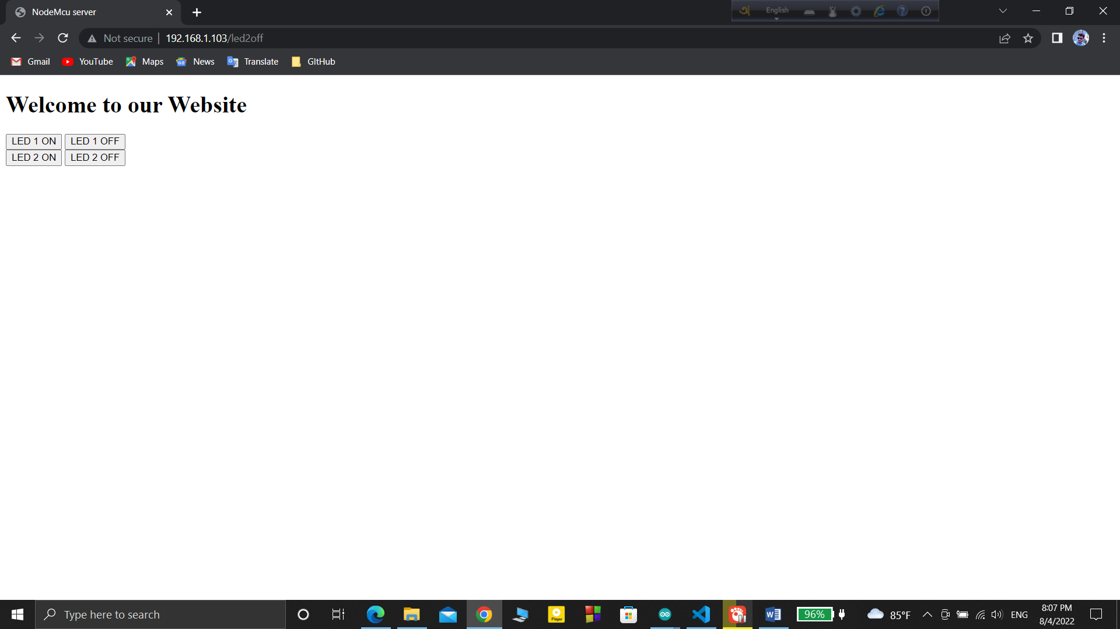

2nd step : connect that Html code to Arduino code .

There we need some commad

client.println("HTTP/1.1 200 ok");  
client.println("Content-Type: text/html");  
client.println();

code:

|  |  |
| --- | --- |
| |  | | --- | | #include<ESP8266WiFi.h> WiFiClient client; WiFiServer server(80);  #define led1 D6 #define led2 D7  void setup() {   // put your setup code here, to run once:   Serial.begin(9600);   WiFi.begin("ICE_Innovation_Lab", "beinnovative#");   while (WiFi.status() != WL_CONNECTED)   {     Serial.print("..");     delay(200);   }   Serial.println();   Serial.println("WiFi is connected");   Serial.println(WiFi.localIP());   server.begin();    pinMode(led1, OUTPUT);   pinMode(led2, OUTPUT); }  void loop() {   // put your main code here, to run repeatedly:   client = server.available();    if (client == 1)   {     String request = client.readStringUntil('\n');     Serial.println(request);     request.trim();     if (request == "GET /led1on HTTP/1.1")     {         digitalWrite(led1,HIGH);     }        if (request == "GET /led1off HTTP/1.1")     {         digitalWrite(led1,LOW);     }      if (request == "GET /led2on HTTP/1.1")     {         digitalWrite(led2,HIGH);     }        if (request == "GET /led2off HTTP/1.1")     {         digitalWrite(led2,LOW);     }    }  client.println("HTTP/1.1 200 ok"); client.println("Content-Type: text/html"); client.println(); client.println("<!DOCTYPE html>"); client.println("<html>"); client.println("<head>"); client.println(" <title>NodeMcu server</title>"); client.println(" <h1>Welcome to our Website</h1>"); client.println(" </head>"); client.println("<body>"); client.println("<a href=\"/led1on\"\"><button>LED 1 ON</button></a>"); client.println("<a href=\"/led1off\"\"><button>LED 1 OFF</button></a>"); client.println("<br>"); client.println("<a href=\"/led2on\"\"><button>LED 2 ON</button></a>"); client.println("<a href=\"/led2off\"\"><button>LED 2 OFF</button></a>"); client.println("</body>"); client.println("</html>");  } | |

After uploading this code into NodeMcu8266

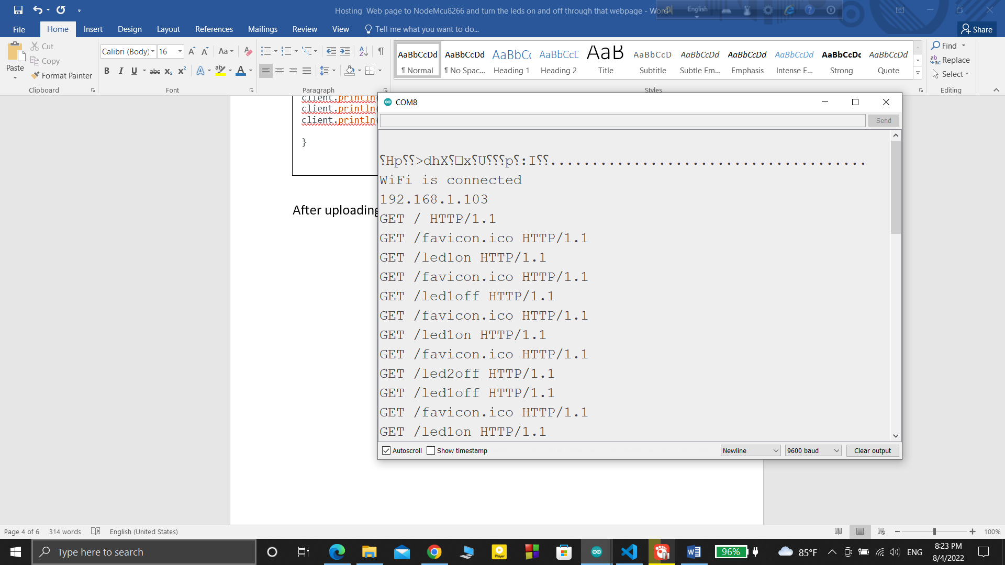

The nodeMcu is connected to the WiFi network and when we paste the ip address in the browser the webpage will open and we will control the node mcu